If you think fatigue may be a problem for you, the Stanford Sleepiness Scale is a quick and easy way to assess how alert you are feeling.

|  |  |
| --- | --- |
| **Degree of Sleepiness** | **Rating** |
| Feeling active, alert, wide awake | 1 |
| Functioning at high levels, but not fully alert | 2 |
| Awake, relaxed, responsive but not fully alert | 3 |
| Somewhat foggy, let down | 4 |
| Foggy, losing interest, slowed down | 5 |
| Sleepy, woozy, fighting sleep | 6 |
| Sleep onset, having dream-like thoughts | 7 |
| Asleep | 8 |

Ideally, you would like a score of 1-3 when operating the pipeline. If you find that you’re beginning to feel foggy and sluggish (rating 4), that’s a sign that you should take a break from the console, do an Alertness Exercise or get a cup of coffee. Any rating below a 4 indicates you could be suffering from a lack of sleep. Getting a better night’s rest may improve your level of alertness and performance. Don’t allow sleep deprivation to impair your health, your job safety, or the safety of others.

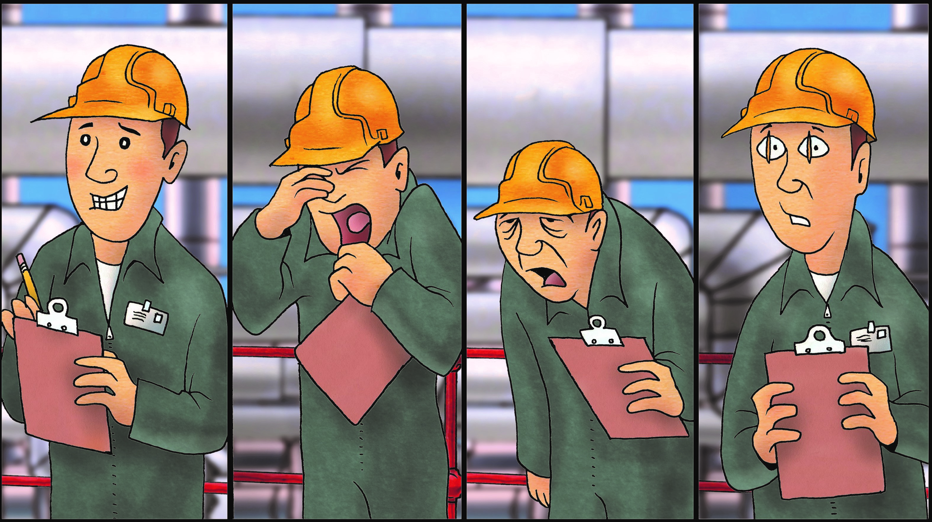

**How to Recognize Signs of Fatigue**

Bill Engvall made the phrase, “Here’s your sign” famous when he made us laugh about people not getting the picture, not understanding the obvious. The fact is, it’s common for all of us, at times, to miss what may be obvious to others.

How good are you at recognizing the signs associated with fatigue? Are you willing to admit fatigue and then do something to correct it? Fatigue left unchecked can be a hazard to one’s job and ultimately one’s health. It’s certainly worth paying attention to this problem that we all experience.

Since fatigue has been cited by the Pipeline and Hazardous Materials Safety Administration (PHMSA) as a risk to safe pipeline operations, it’s worth taking the time to examine signs of fatigue so the appropriate action can be taken to make correction. PHMSA established regulations designed to help pipeline controllers reduce the risks associated with fatigue. The final rule regarding fatigue mitigation requirements was published February 1, 2010. Your company’s policies and procedures surrounding this ruling should be included in your Control Room Management (CRM) plan. This plan should be available to, and understood by everyone controlling and maintaining the pipeline.

One CRM plan defined fatigue as a complex state characterized by a lack of alertness and reduced mental and physical performance, often accompanied by drowsiness. That’s a concise description of what fatigue looks and feels like. Identifying fatigue in an individual is challenging because there’s no chemical test to determine the presence of it like there is for alcohol or other drugs. Therefore, it’s difficult to conclude that fatigue was a contributing factor in an accident. Inspectors may use a list of questions, including hours of service, to decide whether or not fatigue was a causal factor in an accident.

Is fatigue a problem for you? Do you regularly pay back your sleep debt with the recommended eight hours of sleep? Do you allow sleep debt to accumulate? Cumulative fatigue can pose significant risk to your health including cognitive impairment, memory lapses, impaired immune system, risk of obesity, risk of Type 2 diabetes, and even the increased risk of heart disease.

**JULY 2019**