In the United States and Canada, clean water is readily available so there’s no reason for those of us living in these and many other countries to suffer the host of consequences associated with dehydration. Our bodies can take water from the fruits and vegetables we eat. Water is also acquired from non-caffeinated, non-alcoholic beverages. Even bathing provides hydration, as our skin, our largest organ, absorbs water. To give our bodies the hydration it truly needs, we should drink about two liters of water every day.

Water is considered to be a “miracle cure” for many health conditions.

* As a lubricant, water helps prevent arthritis and back pain.
* Water increases the efficiency of the immune system.
* Water is needed for the efficient manufacturing of neurotransmitters, including serotonin.
* Water is needed for the production of hormones made by the brain, such as melatonin.
* Water improves our attention span.
* Water helps prevent clogging of arteries in the heart and brain.
* Water reduces many of the negative effects of aging.

Drink a glass of water to stay alert and to thrive!

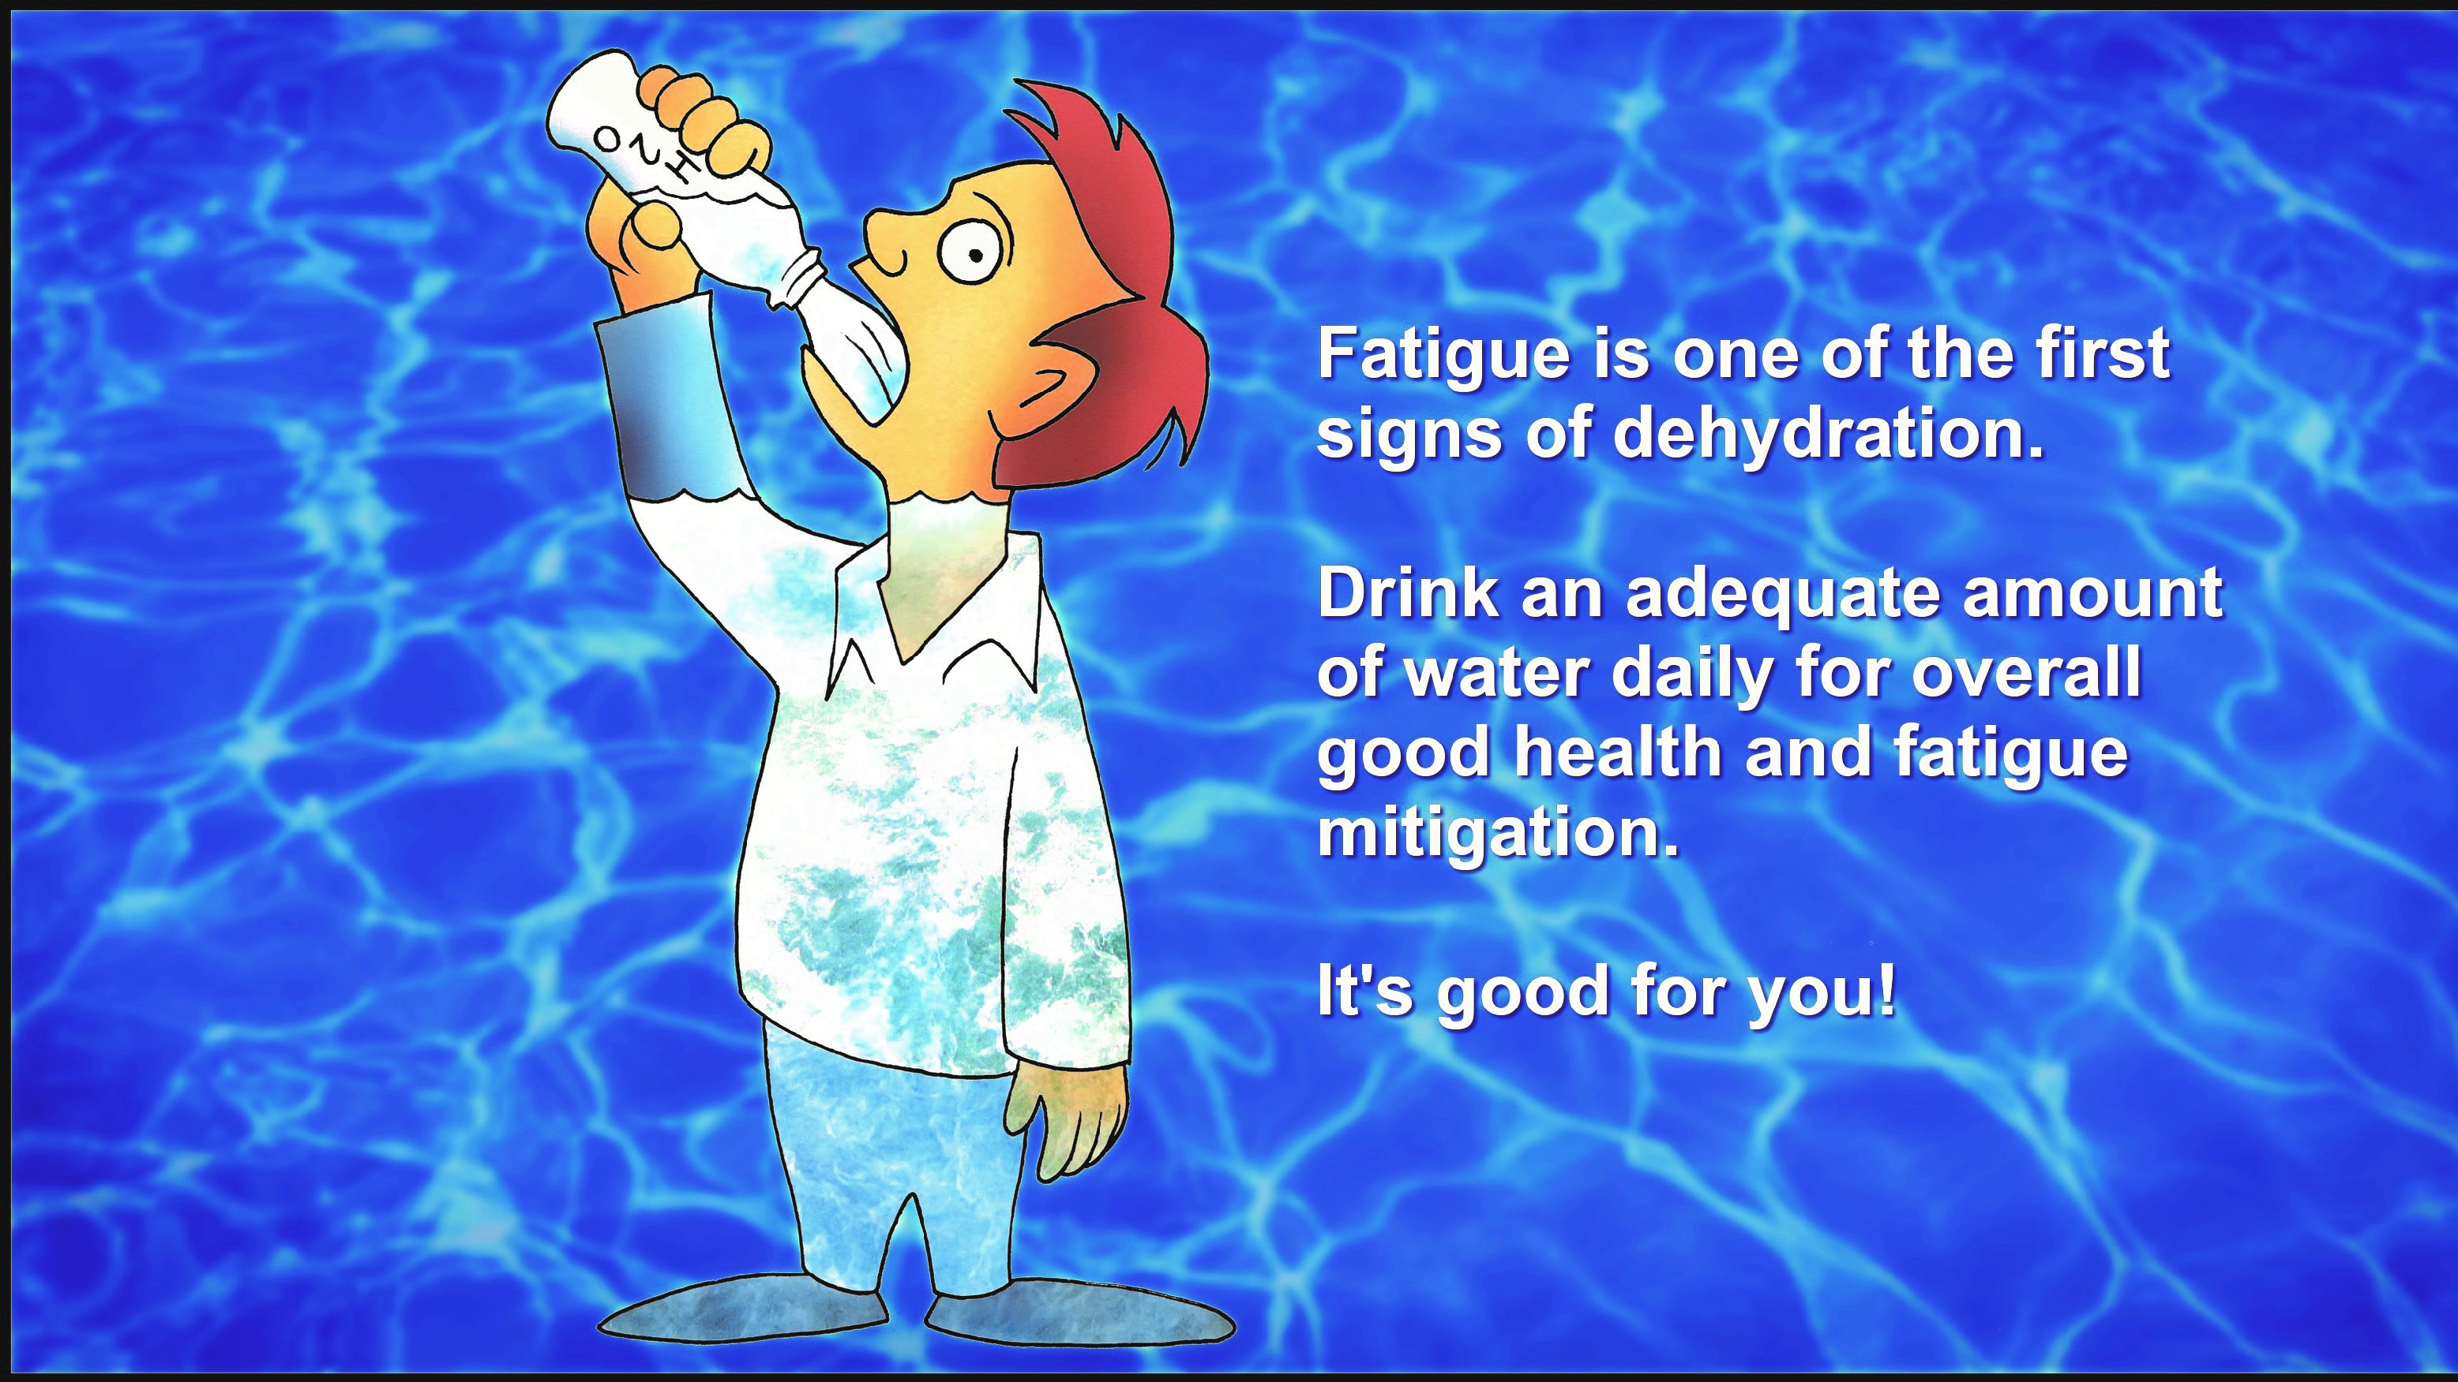

**The Importance of Water**

Water is the primary foundational component of health. It’s known to be the most important nutrient we take in because it’s involved in every function of our bodies. Our muscles are about 75% water. Our brain cells are about 85% water. Our blood is approximately 82% water. Even our bones are about 25% water. Drinking sufficient amounts of clean water is an effective way to significantly improve your health.

Hydration is important for everyone, especially for people working in warm climates, those who are physically active, and for Controllers sitting at the console. Why is it so important for Controllers, you may ask? Aren’t they sitting in climate-controlled spaces with limited physical exertion required? Adequate hydration is very important for anyone who needs to stay alert for extended periods of time. Alertness levels are directly affected by adequate hydration or the lack thereof.

Because brain cells are made of mostly water, dehydration can cause big problems for cell function. The cell wall becomes less pliable when dehydrated. Rigid cell walls hinder oxygen-rich blood from entering the cells and also hinder waste from leaving the cells. Fatigue is a byproduct of brain cells that aren’t functioning efficiently. Dehydration also negatively affects sodium and electrolyte levels in the body, which has been linked to cognitive decline. The simple act of drinking water can refresh brain cells and wash away fatigue and headaches.

When your body lacks the amount of water it needs, it smartly rations what it does have to support the function of the top five vital organs: brain, heart, lungs, liver, and kidneys. The skin, gastrointestinal tract, and joints also suffer symptoms of dehydration when not enough water is present in the body. If the starting five suffer dehydration, a host of serious consequences can result. More serious consequences of dehydration include seizures, loss of consciousness, low blood volume, kidney failure, coma, and even death.

**AUGUST 2019**