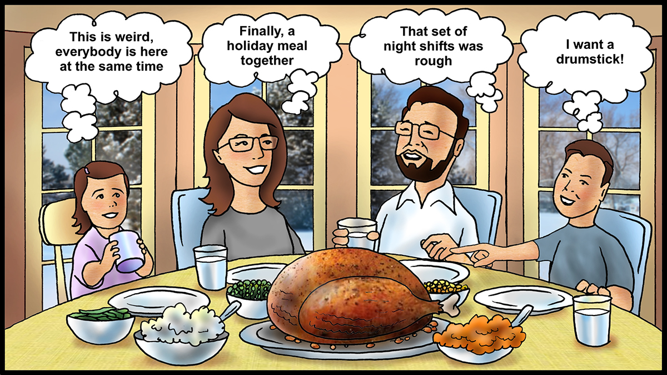

The two key actions for family gatherings are advance planning and communication. Do not delay either of those actions because you dread telling others you have to work on holidays. It is difficult; no it is impossible to please all members of a family. Even people who do not ever work holidays cannot please all the people who want to see them on holidays. Life and relationships are complicated nowadays. I do not think it is possible to achieve work and life balance. Stop stressing about balance. It is all just life.

If it is the year when you are scheduled to work on holidays, work your scheduled shifts so that those who are supposed to be off can be with their families. Some of those years I worked overtime on holidays were when a coworker was “sick.” I know that does not happen in today’s control rooms since all of you practice teamwork and professionalism.

No matter what day you celebrate, enjoy the time together by focusing on the people you are with at the time. Seek to get an adequate amount of sleep so that you can recover from the effects of working shifts. It would not be polite to fall asleep at the communal table.

It looks like I have painted a bleak picture of being a shiftworker during the holidays. My intent is to be realistic and to offer suggestions to reduce your stress. Thanks for reading these managing fatigue articles this year and using the calendars. Merry Christmas!

**FAMILY GATHERING**

In The Lost Country by William Gay, there is a passage about a hospital that is appropriate for those who work shift work anywhere. I am modifying it slightly. *Here in this glow of cold white fluorescence even time was held in abeyance. The sun neither rose nor set. The lights never went out, so day never ended, nothing marked time’s wheeling save the changing of shifts, the hours of [control and monitoring], hello and goodbye. The changing faces of the [pipeliners].*

If you have read any of Gay’s writings, you know he paints a bleak picture of humankind. He writes about working people in the South. At this time of year, we want to think of thanksgiving, of holiday preparations, of family gatherings. We want to be like the family in the picture, all together at the table. Yet someone has to work the day shift and the night shift on holidays. While there may be additional compensation in some companies, most of us would prefer to be at home.

We do not want to be in the glow of overhead lights; even if they are fancy lights that can help our circadian rhythms cope with night shift hours. While time may be held in abeyance in the control room, it marches steadily on for our families and friends who plan events. They do not understand why we cannot be present. It is particularly difficult for young children to understand why a parent is absent. I remember one Christmas day when our preschool sons waited until I got home after dayshift to open their presents. That was painful for them. We adjusted our celebrations after that year to observe the holiday on one of my off days before the actual day. That works for the nuclear family even if it does not work for the extended family.

When I was a shiftworker who only had one weekend off a month, I adopted a philosophy from Romans 14:5 (NRSV): *Some judge one day to be better than another, while others judge all days to be alike. Let all be fully convinced in their own minds.* I judged one day to be no better than another, and we planned our activities and holiday gatherings on days off even if some members of the extended family thought a holiday had to be celebrated on the actual date. Since I knew my shift schedule at the beginning of the calendar year, I could communicate well in advance when I could be available for events. Some years even those plans changed when I worked overtime.

**DECEMBER 2018**