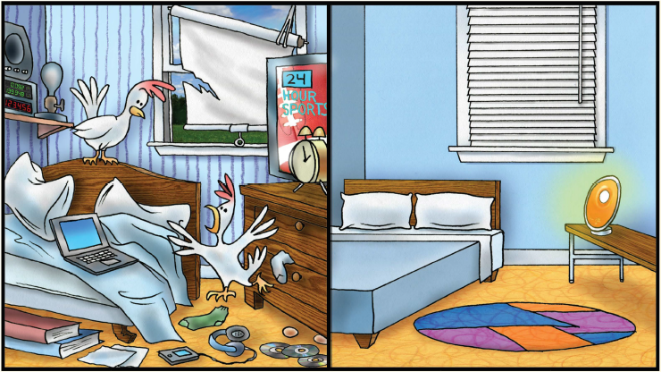

Living in a cluttered environment may increase the level of a hormone in your bloodstream called cortisol. Elevated levels of cortisol are known to increase fat deposits around the waistline which puts added pressure on the heart. Too much cortisol can result in negative changes in brain function, reducing your effectiveness in relationships and on the job.

This year set a goal to enjoy a great night’s sleep! Here are some suggestions to help you create action steps:

* Remove clutter from your bedroom.
* Remove items that distract from sleep, like technology.
* Replace your mattress every 7 years.
* Keep bedding fresh, clean, and comfortable.
* Paint the walls white, gray or sky blue to enhance calm.
* Blackout shades provide the darkness deep sleep requires.
* Use adjustable lighting for reading books.
* A cozy rug under the bed adds a feeling of bliss.

Start the new year with a good night’s sleep and you’re likely to discover this is the best year yet!

**REFRESH YOUR SLEEP ENVIRONMENT**

Are you one to set goals for yourself at the start of a new year? Even if you haven’t had great success completing the steps to meet your goals in the past, the milestone of a new year seems like a good time to try again. If you’re like most people, some of your attempts at achievement were hijacked by the demands of everyday life, especially the life of a shift worker. Maybe you failed at reaching for a high and lofty goal because you were simply too tired to climb another rung.

The simplest way to meet a goal is to first decide on one that’s meaningful and attainable. Can you visualize yourself enjoying the reward that meeting the goal would bring? One of the most worthy goals any of us can work toward is a better night’s sleep. How would your life change if you were getting seven or eight hours of sleep on a regular basis?

Shift workers have more challenges when it comes to getting enough sleep than those who work daytime hours only. The human body is designed to be active and alert in daylight and asleep at night. Shiftwork disrupts this circadian rhythm, requiring shift workers to be very intentional about getting the sleep their body needs in order to function at peak performance.

Everyone knows sleep is the bedrock that all activity is built on. Without proper sleep, productivity grinds to a halt. The list of things we all allow to overshadow a full night of sleep can be long. That list may include interruptions from family and friends when working the night-shift, binge watching an exciting new series, working overtime, or simply keeping clutter in the bedroom. Think clutter is no big deal? Think again!

A cluttered environment leaves us feeling out of control. The stress associated with clutter can increase fatigue and depression. The negative effects of a cluttered environment also decrease our ability to focus. In off-duty hours, shouldn’t shift workers be focused on getting the rest they need?

**JANUARY 2019**