Pipeliner work falls in the high-risk category, and as such, your ability to concentrate is very important. Fatigue can reduce your power of concentration and negatively affect your ability to monitor operations.

Along with physical and psychological impacts, fatigue affects our emotions. Many factors contribute to poor morale in the workplace, and fatigue makes these factors worse. Communication often suffers when you are fatigued. You may notice being more prone to complain, argue, or ignore other people when you are tired. Certainly, if an overly fatigued worker is not feeling well, is terse in their communication, and makes mistakes in monitoring, morale is negatively impacted. A person who is not getting the sufficient quantity and quality of sleep necessary for alertness, may be unreasonably moody or withdrawn. How’s your mood been lately? Perhaps a few more hours of sleep would be of great benefit to you and others.

Sleep is the only means for mitigating fatigue, or for “repaying your sleep debt.” Your sleep debt slows down your productivity and accuracy. Don’t be caught lacking! Avoid the negative impacts of fatigue on your physical, mental, and emotion health. Plan wisely and sleep well.

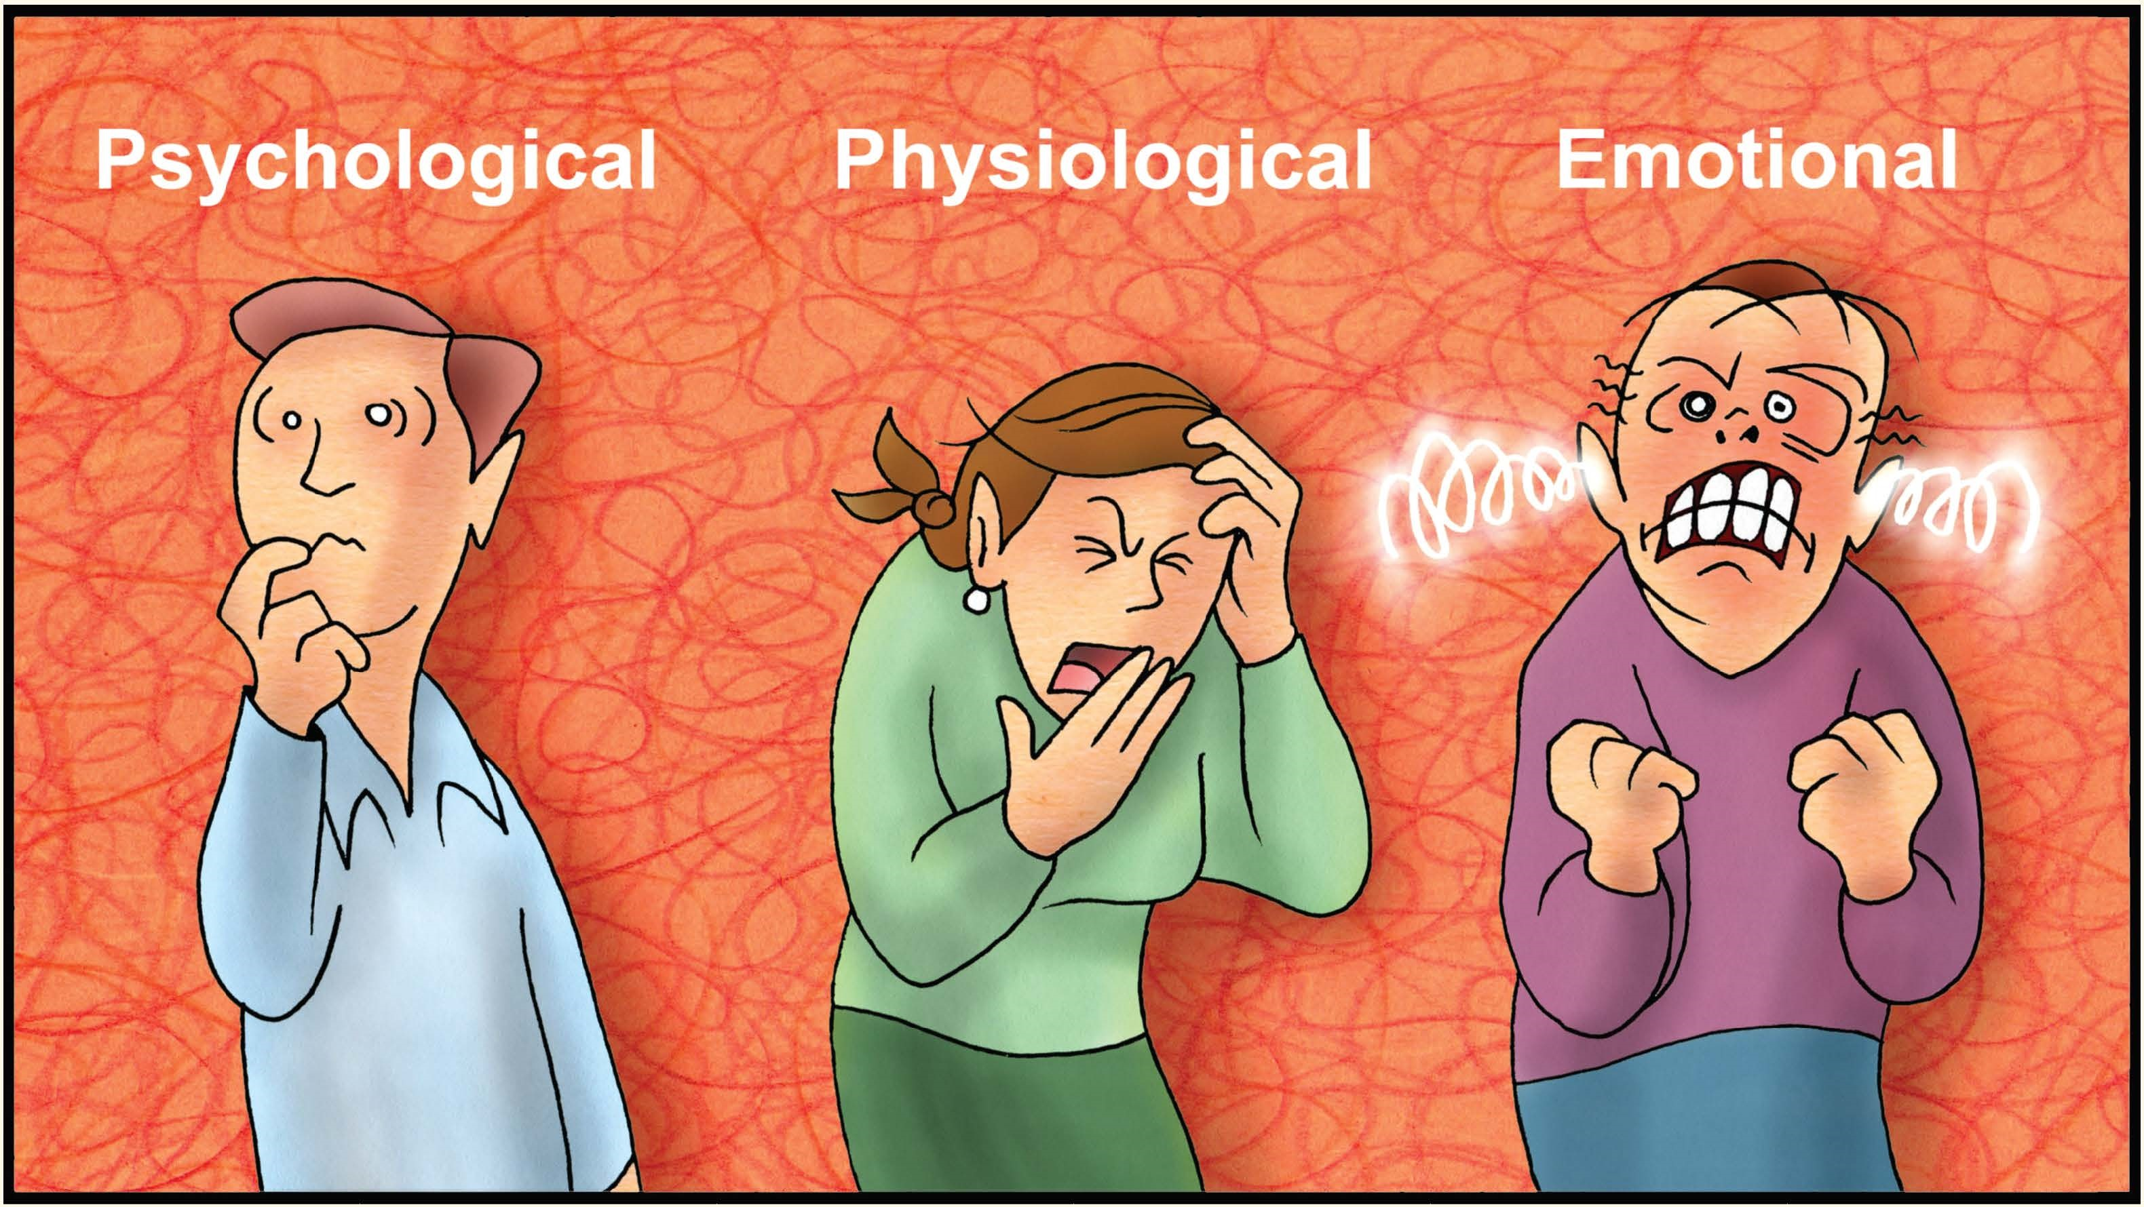

**How Does Fatigue Affect You?**

Fatigue can be defined as a *complex* state characterized by a lack of alertness and reduced mental and physical performance, often accompanied by drowsiness. Each one of us has experienced fatigue. How often do you feel fatigued? At what level do you feel fatigued?

Because there’s no chemical test to identify the presence of fatigue in our bodies as there is for identifying the presence of drugs or alcohol, we must consider several factors to help identify its presence:

* How long have you been awake?
* How much sleep have you gotten?
* What time is it? Are you experiencing a lull in your circadian rhythm?

Once fatigue has been determined, it’s important to realize that it may affect you in a variety of ways. Your reaction time may be slower, or you may not react at all because a fatigued mind seeks short-cuts to conserve energy. In an effort to conserve energy, your senses may be dulled. Certainly, a fatigued person suffers a lack of energy and may feel weaker than normal. Have you experienced headaches and nausea when fatigued? These symptoms can be very distracting when focusing on tasks. One of the most dangerous physiological effects of fatigue is experiencing micro-sleeps. This is best defined as your brain grabbing a quick nap without your permission. It happens when the brain realizes the urgent need for sleep. In response to this, the brain involuntarily and momentarily shuts down. More seriously, cumulative and chronic fatigue may lead to serious health problems such as an impaired immune system, increased risk of Type II Diabetes, an increased risk of heart disease and obesity.

Fatigue also has a psychological and cognitive impact on shift-workers. We can see its effects on thinking when you make poor decisions. You are less likely to go through all steps of the decision-making process when overly fatigued. Memory loss, another effect of fatigue, may contribute to poor decision-making.

**NOVEMBER 2019**