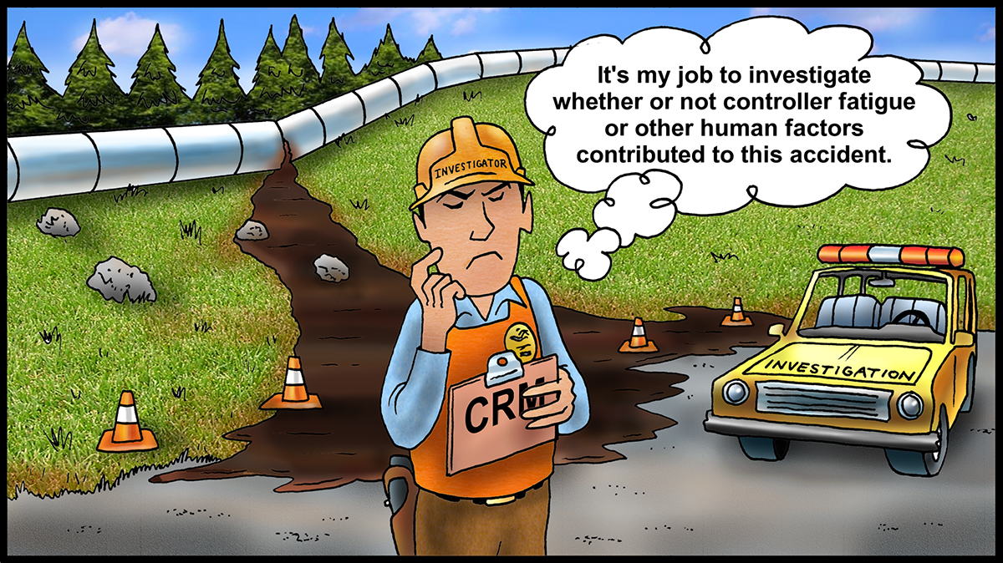

Those questions could come from the “NTSB Methodology for Investigating Operator Fatigue in a Transportation Accident” or “Investigating the Possible Contributions of Fatigue to Pipeline Mishaps” white paper by Dr. James C. Miller.

In the CRM programs we develop, we include the questions from the NTSB method in the Fatigue Risk Management Systems and develop a “Fatigue Incident Analysis Quantification” form that can be used in incident analysis. As you can imagine, it requires asking the person questions about recent sleep history and other factors. Those include:

* How much sleep did you get in the past 24 hours?
* How much sleep did you get in the past 48 hours?
* How much sleep did you get in the past 72 hours?
* What time did you awake before reporting to work?
* Have you been experiencing any sleep problems?

We believe it is important to also analyze the contribution of other human factors to incidents. Those include stress, distractions, complacency, job pressure, lack of awareness, lack of assertiveness, and lack of communication. The effects of fatigue can combine with any or all of those factors to cause errors and accidents. It is worthwhile to analyze the causes of accidents in order to prevent future incidents. What are you doing to learn how fatigue contributes to operating incidents?

**Investigating Fatigue Factors**

In planning this article, I recalled an operational near miss with my fatigue as the cause. In the 1980s I worked eight hour shifts. I decided to go to college, and enrolled for daytime classes. Since our day shifts were from Thursday through Tuesday, I exchanged my day shift on Thursday and worked night shift before going to class Friday. I exchanged my Monday day shift for an evening shift, and then doubled back for the Tuesday day shift. I was also a bivocational minister and often exchanged shifts in order to participate in services on Sunday morning and evening. My wife says I did not sleep much for four and one-half years. I experienced both chronic and cumulative fatigue. It took a toll physically, mentally, emotionally, and spiritually.

On one night shift, I started a delivery of gasoline to the Texaco terminal. I called Wayne Sewell and he asked me to call him at 200 barrels so he could switch tanks. It took five minutes to pump 200 barrels. During the five minutes, I fell fast asleep. The phone ringing awakened me. Fortunately Wayne was watching the product stream in the sample house and switched tanks on time. This prevented product contamination. If companies investigated incidents during those times, I would have been at fault.

Today, there is a CRM requirement that reportable pipeline accidents with controller involvement need to determine if fatigue was a contributing factor. If it is, the potential contribution of fatigue is supposed to be quantified. I am learning that some companies pay scant attention to whether or not fatigue or other human factors contribute to near misses, operating errors, or pipeline accidents. What occurs is that the investigator asks the person if he was fatigued or not. If the person says no, then fatigue is not considered. That is shortsighted since it is likely that most people working rotating shifts have some level of fatigue, particularly on night shifts.

I recommend an approach that begins with a FAID software analysis of the hours of work of the person involved in the incident. That analysis should include the past seven days of work and the shift when the accident occurred. The analysis can quantify the potential level of fatigue at the time of the incident. If the FAID fatigue level number is in the red zone, the investigator should not stop there but should ask additional questions.

**SEPTEMBER 2018**