**OCTOBER 2017**

Last weekend on the way to a music festival, I saw a billboard that caught my eye since it was about working shifts. The message I received from the ad is that the equipment can work around the clock. But even equipment requires routine and preventive maintenance to work those two shifts.

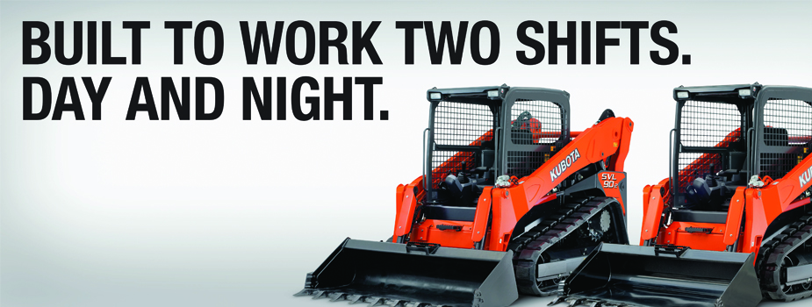

There is something else that the equipment requires in order to work two shifts. That is a picture of a human equipment operator. Perhaps the human is omitted because one human is not built to work two shifts.

Although some of us have worked two consecutive shifts or longer at some point, it was evident I was not designed to do so. I recognized the effects of fatigue after about 19 hours and all I wanted to do was sleep even though the shift lasted another 17 hours and then I had to drive home.

That was stupid planning on the part of the company and stupid of me to work that many hours in a row. I hope and pray that companies and individuals have implemented better work scheduling practices, have adequate staffing, and are practicing personal sleep habits that reduce the risks of a pipeline related accident that can lead to the harm of employees, the public, and the environment.

**Recognizing Fatigue**

We know intellectually that we need to sleep about eight hours after we have been awake for about 16 hours. My granddaughter does not appreciate that concept and seeks to delay bedtime. My grandson will sometimes ask if he can go to sleep before the scheduled bedtime because he is tired. My granddaughter will never admit to being tired. It is not just about intellect: our emotions and desires influence whether or not we recognize when we are fatigued and need sleep or rest. Are you one who recognizes fatigue or do you deny it?

We may have an inkling that we are fatigued, but choose to keep going on the job or off the job. One thing that has helped me make better choices occasionally is writing these fatigue management articles since 2011. Even a stupid person can recognize the need to sleep after reading and researching about sleep, fatigue, stress, workload, health and well being in order to help others learn about those subjects. Another thing that has helped me is that I get a message from my Fitbit every night at 9:30 that it is time to wind down and get ready for sleep. That regular cue prompts me to stop whatever I am doing and to prepare for sleep. Sleep is beneficial.

If you are subject to the Control Room Management regulations, you should know by now that one of the requirements is to “train controllers and supervisors to recognize the effects of fatigue.” In our fatigue training and on the inside cover of our calendars, we provide a “Fatigue Observations Checklist” that some people use to monitor for signs of fatigue. Those signs are what you would expect: yawning, long eye blinks, slowed speech, head nods, and microsleeps. Those are visible effects of fatigue and can be seen in control rooms and other places at times when our circadian rhythms are driving us to sleep. Those are the effects of fatigue that should lead workers to use fatigue countermeasures, including taking breaks from the console.

How do you train controllers and supervisors to recognize the effects of fatigue? I think it is beneficial to remind people that there are two competing forces: those that produce fatigue and those that reverse the effects of fatigue. **Being awake is the primary force that produces fatigue; sleep is the only effective force to reverse the effects of fatigue.** Other related forces that produce fatigue are concentrated mental effort, sustained physical exertion, being awake and working during windows of circadian lows (WOCL). There are reasons why it is necessary to evaluate and to address both task-related fatigue and sleep-related fatigue. Sometimes we do not consider how noises, lighting, ventilation, ergonomics, and other environmental factors produce fatigue and do not take actions to address those effects.

